Parth Babbar

Consumer Financial protection bureau

**Introduction:**

The Consumer Financial Protection Bureau (CFPB) is a regulatory body of the United States government in charge of supervising financial goods and services available to consumers. It was intended to protect consumers against unfair, fraudulent, or abusive activities, as well as to provide customers with clear and accurate information to help them make educated financial decisions.

**History:**

President Barack Obama signed the Dodd-Frank Wall Street Reform and Consumer Protection Act, which established the Consumer Financial Protection Bureau (CFPB) in 2010. It officially began operations on July 21, 2011. The bureau was established to centralise and streamline monitoring of consumer financial goods and services, with the goal of providing better protection to consumers.  
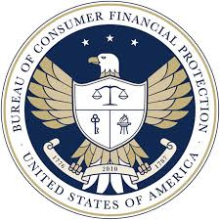

**Governance:**

The Consumer Financial Protection Bureau is an autonomous organisation inside the Federal Reserve System. It is managed by a Director, who is selected by the President and ratified by the Senate for a five-year period.

**Objectives:**

The Consumer Financial Protection Bureau (CFPB) is committed to many major objectives:

1. **Consumer Protection:** Enforcing federal consumer financial rules to ensure equal treatment for all customers.
2. **Education:** Through comprehensive education campaigns, individuals are empowered with the knowledge they need to make healthy financial decisions.
3. **Research:** Engaging in intelligent research to obtain a better knowledge of consumer financial markets and behaviour.
4. **Complaints:** Serving as a responsive platform for collecting, investigating, and addressing consumer grievances, ensuring swift resolution.
5. **Financial Innovation:** Fostering an atmosphere of equal competition and innovation in the financial services sector, assuring development while upholding fair practices.

**Function:**

1. **Supervision:** The CFPB regulates around 60% of the mortgage industry and controls over 5,000 banks and credit unions.
2. **Enforcement:** Since its founding, the CFPB has obtained over $14 billion in redress for more than 35 million customers affected by financial institutions' conduct.
3. **Rules:** Since its creation, the CFPB has produced more than 50 rules and regulations relating to consumer financial protection.
4. **Consumer Awareness:** The CFPB's instructional campaigns have reached millions of customers via a variety of venues, including its website, social media platforms, and community outreach programmes.   
     
   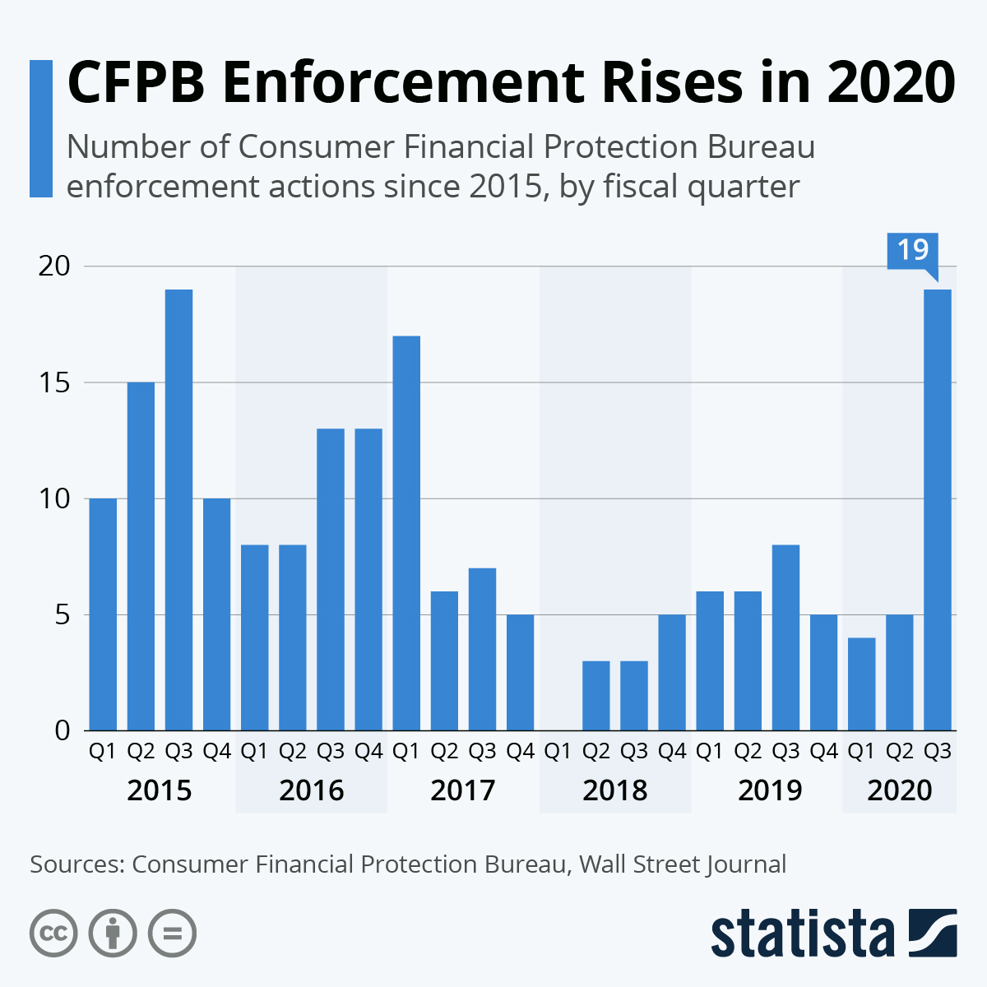

**Conclusion:**

The Consumer Financial Protection Bureau is critical to protecting American consumers in the financial markets. Despite criticism and hurdles, the organization's efforts to enforce consumer protection legislation, educate customers, and promote fair financial practices have had a substantial beneficial influence on the financial industry and consumers' rights.